Part I

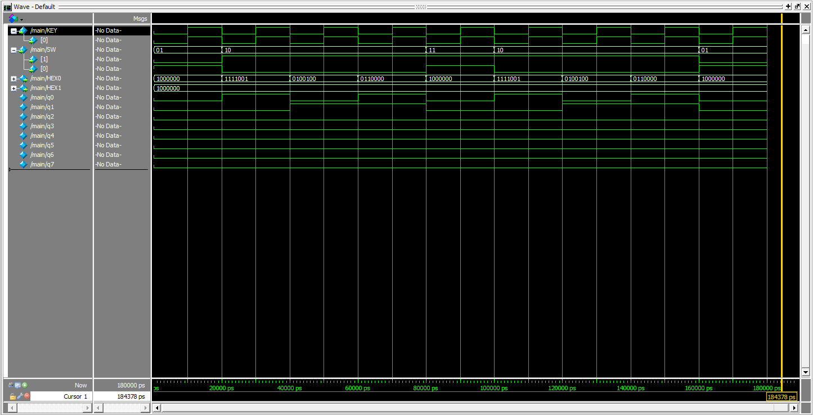

Reset

Reset to 00000000

Enable

CLOCK

Sequence is repeated, from what the instructor: Karthik, “…Once you know it can count from 1 to 10 say, do you rly need to confirm that it can keep on counting to 1 million?”

I think this warrants the flexibility of the simulation test cases, considering ECE 2T2 students have a ECE244 midterm today.

Reset to 00000000

Reset to 00000000

00000010 + 00000001 =

00000011

00000001 + 00000001 =

00000010

00000000 + 00000001 =

00000001

Reset to 00000000

Part I – RTL Viewer Schematic

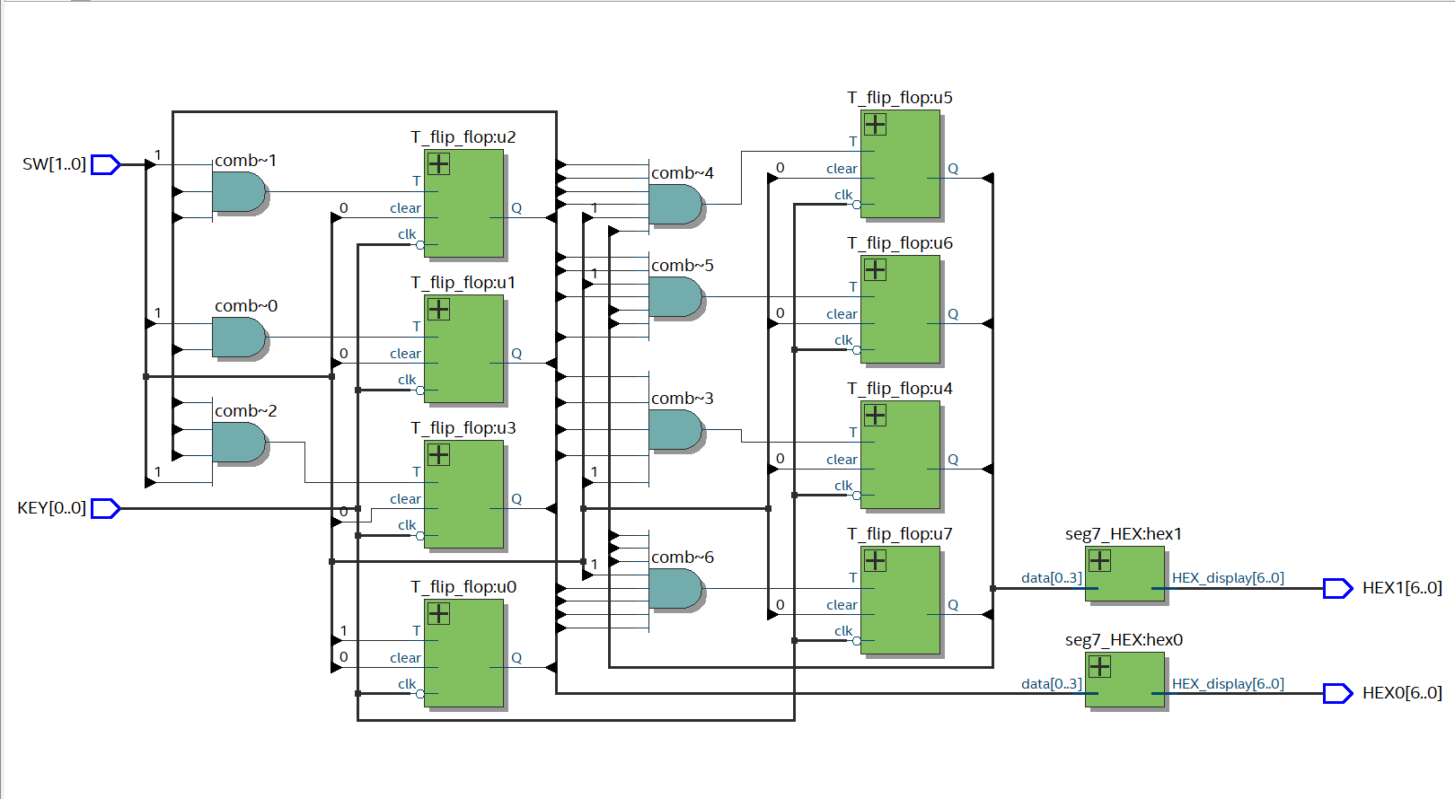

Part II – 50 MHz

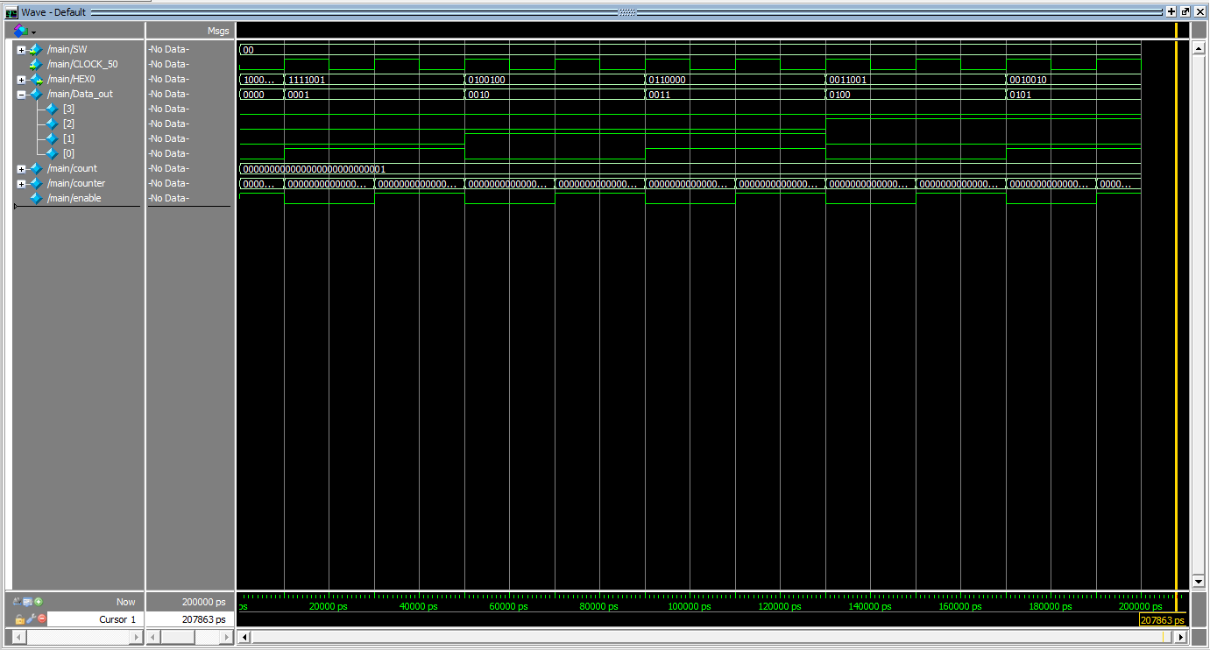

Increment to 0101

Increment to 0100

Increment to 0011

Increment to 0010

Increment to 0001

Reset to

0000

The changes are seen in Data_out

Part II – 2 Hz

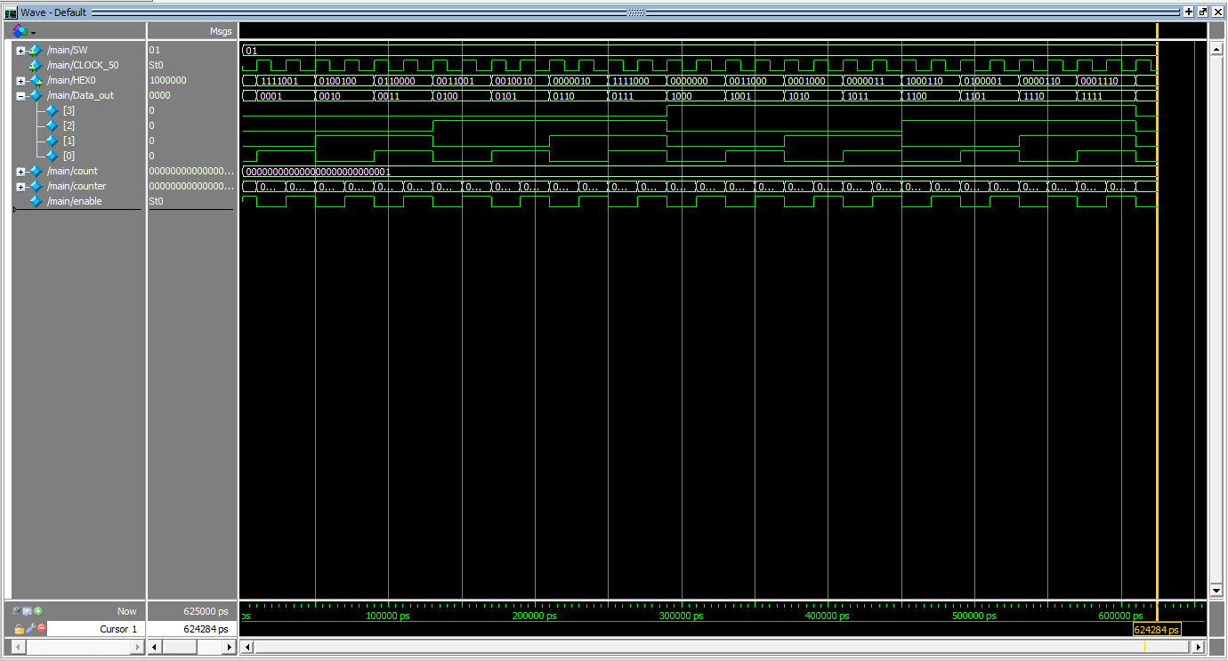

I++

0000

I++

1111

I++

1101

I++

1110

I++

1100

I++

1011

I++

1010

I++

1001

I++

1000

I++

0111

I++

0110

I++

0101

I++

0100

I++

0011

I++

0010

CLK Signal

I++

0001

The changes are seen in Data_out

Reset to 0000 at start

Part II – 1 Hz (Similarly to before, just slower)

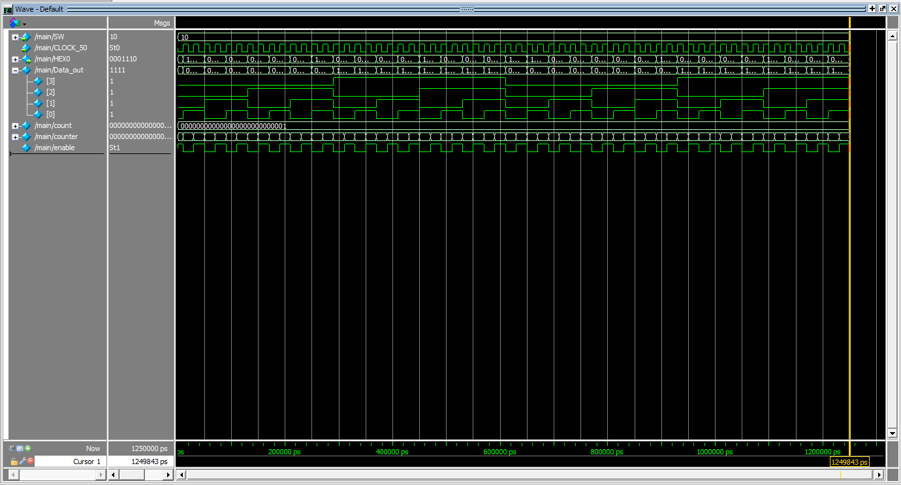

Part II – 0.5 Hz (Similarly to before, just even slower)

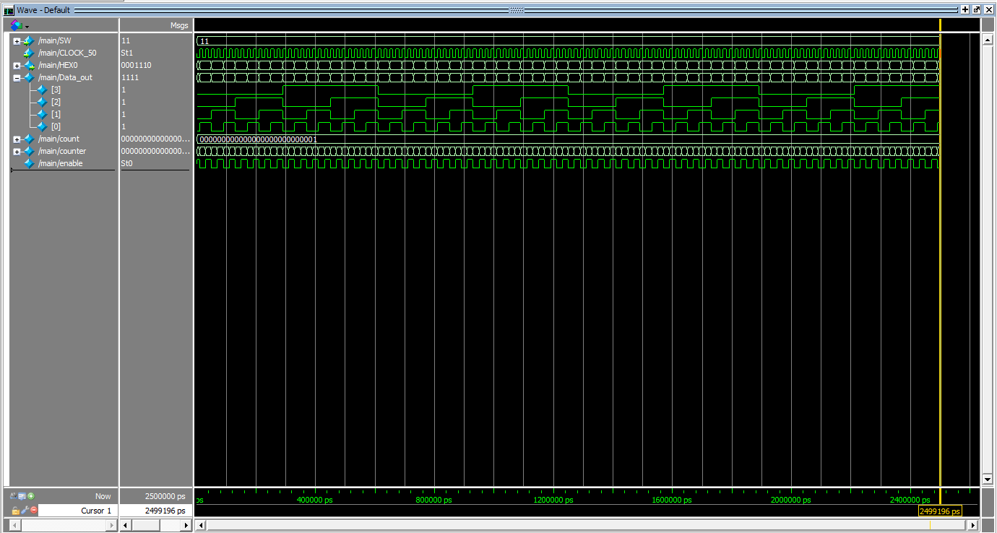

Part III

*Cropped to have enough simulation work while being environmentally friendly*

****MorseCode displays the Morse code data, whereas LEDR displays the sequence as it occurs****

Morse Code of I(..)



dot

dot

Morse Code of J(.---)



dot

dash

dash

dash

Morse Code of K(-.-)



dash

dash

dot

Morse Code of L (.-..)



dot

dot

dot

dash

Morse code of M(--)



dash

dash

Morse code of N(-.)



dot

dash

Morse code of O(---)



dash

dash

dash

Morse Code of P(.--.)



dot

dot

dash

dash